Project Tender

Project: Traffic Camera Image Analysis System  
Client: Department of defence, peace, safety and security, at the council for scientific and industrial research. (DPSS, CSIR)

Team: Ambitious Designs  
Killian Kieck, Stephen Swanepoel, Dian Veldsman, Tim Kirker  
Department of Computer Science, University of Pretoria

Date: 01 / 05 / 2016

The Team

**Killian Ferdinand Noel Kieck**

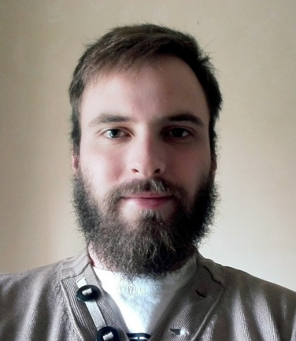

**Interests**

* Programming.
* Reading.
* Sports.
* Technology.
* Space.
* Gaming.

**Technical Skills**

* Information Technology.
* Coding / Programming (Java, C, C#, C++, JavaScript / jQuery, HTML / css, android).
* Database design and management.
* Software design and development.
* Computer networking.
* Testing.

**Past experience**

* Web design.

**Non-technical strengths**

* Quick Learner.
* Communications skills.
* Initiative.

**Why I want to do the project:**

Android development has always peeked my interests and this is a great opportunity to improve on my android development skills and obtain a knowledge on image processing libraries, a challenging but interesting project which is also exciting because it gives people a new method to deal with traffic.

**Stephen Swanepoel**

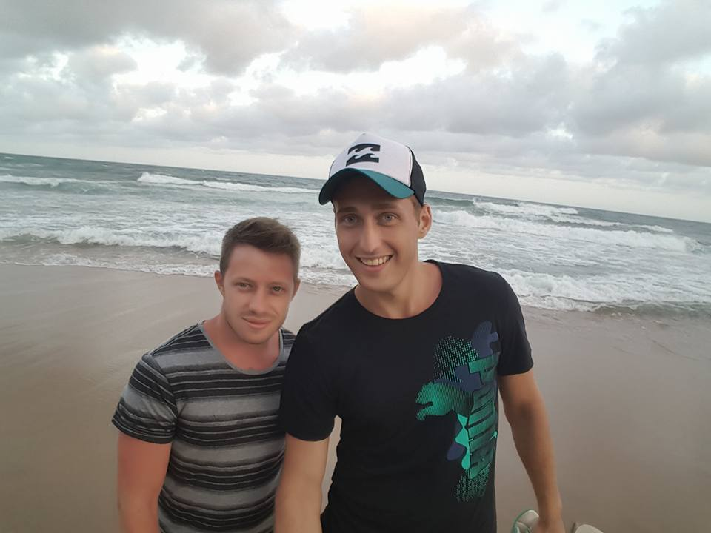

**Interests**

* Programming.
* Nature and wildlife.
* Sports.
* Technology.

**Technical Skills**

* Information Technology.
* Programming (Java, C, C#, C++, JavaScript / jQuery, HTML, CSS).
* Database design and management.
* Software design and development.
* Computer networking.
* Testing.

**Past experience**

* Web design.

**Non-technical strengths**

* Quick Learner.
* Good communications skills.
* Initiative.
* Team player.

**Why I want to do the project:**

From a developers aspect I am interested in this project as I feel it will push me out of my comfort zone and become an interesting learning outcome. I will be exploring new technology which is vital to me as I would like to obtain a strong and diverse skill set regarding software development. Working on an image processing system would assist me in my personal goals to diversify my skill set. On a personal level I dislike traffic and would enjoy being able to design software to assist mine and others’ daily encounters.

**Dian Veldsman**

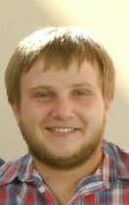

**Interests**

* Programming
* Reading
* Technology
* Gaming
* Watching Movies
* Snooker
* Surfing the Internet

**Technical Skills**

* Information Technology
* Coding / Programming (Java, C, C#, C++, JavaScript / jQuery, HTML / css, android, Python)
* Database design and management
* Software design and development
* Computer networking
* GoF Design Patterns
* Concurrent Systems
* Testing

**Past experience**

* Web design
* Android development

**Non-technical strengths**

* Good coding habits
* Active participation
* Problem solving
* Willingness to learn
* Team player
* Hard working

**Why I want to do the project:**

Traffic is a problem that is on a daily basis. It is a problem that can be avoided by drivers if it was detected beforehand. The application allows me, as developer and fellow driver, to warn drivers of traffic incidents on the road so that they will be able to avoid them and choose an alternative route. This application will also allow me to learn new and diverse set of skills in the form of image processing.

**Tim Kirker**

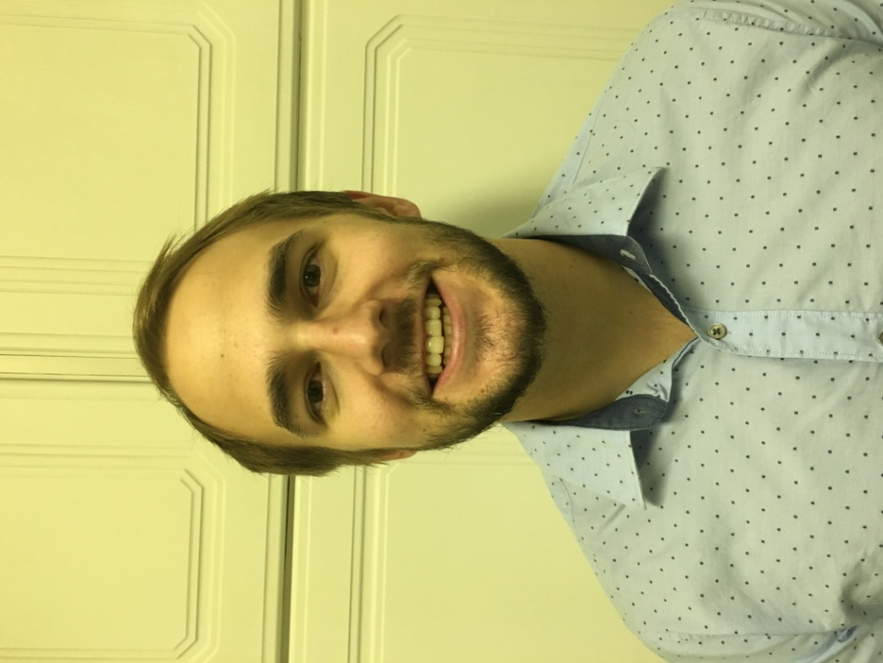

**Interests**

* Sporting activities (both spectating as well as participating).
* Computing whether it be programming or online gaming.
* Music (both listening to it as well as playing musical instruments).
* Reading and keeping up to date with current affairs.

**Technical Skills**

* Programming (Java, C++, JavaScript, Microsoft access, PHP and android development).

**Past experience**

* Free-lance web developer, mathematics tutor and various promotional jobs in the retail sector.

**Non-technical strengths**

* Outgoing
* Good communications skills.
* Hard working.
* Diligent.
* Work well under pressure.

**Why I want to do the project:**

Traffic is a major dilemma for most people in their everyday lives. Being a TUKS student, living in Johannesburg, I endure traffic incidents on the highway, which with an application giving me up to date information on my route, I could have avoided using alternative routes. Being involved in a project like this is a massive opportunity for me to help others experiencing my same dilemma on a daily basis. It would also give me the chance to improve my skill set and knowledge.

Project Execution

**Development methodology:**   
  
We have decided to use the agile methodology as it allows us to deliver working segments frequently to you (the client), allows for regular adaption to changing circumstances and forces us to continuously look over the software with each new feature release to ensure continuous attention to technical excellence as well as a good design.

**How we intend to keep you informed about the status of your project:**Correspondence via email as well as a few scheduled meetings.

**Initial ideas for solving some of the technical challenges:**   
  
Extensive research will be done into any and all problems, with having little to no experience with such a project we are unaware of most of the technical issues we will be facing which makes it difficult to state how we would approach solving them. Team effort will be a key factor to the success of this project.

**Technologies we plan on using:**We have looked at using java for the project as it is widely supported with software previously written which will enable us to use as the building blocks to our own software. C# for the web server.

**What you (the client) will receive at the end of the project:**

* Original tender document.
* Requirements specification.
* Architecture and Design Document.
* Developers Guide.
* All the project source code.